LaPave

Notes:

Cells with Blue background are data entry fields
Open a copy of LaPave to follow along
The tabs are listed in order that they appear in LaPave
The Excel version of LaPave is JMF specific. Each JMF has its own LaPave file. One LaPave, One JMF.
The last page is a guide for the roadway.

Reporting Tab
The district lab:
Download the latest version of LaPave from the “Public Share Folder” that is provided by the Materials Lab (section 22)
On the reporting tab:
- “Check for Latest Version” of LaPave
- “Update Material Codes from the Server” 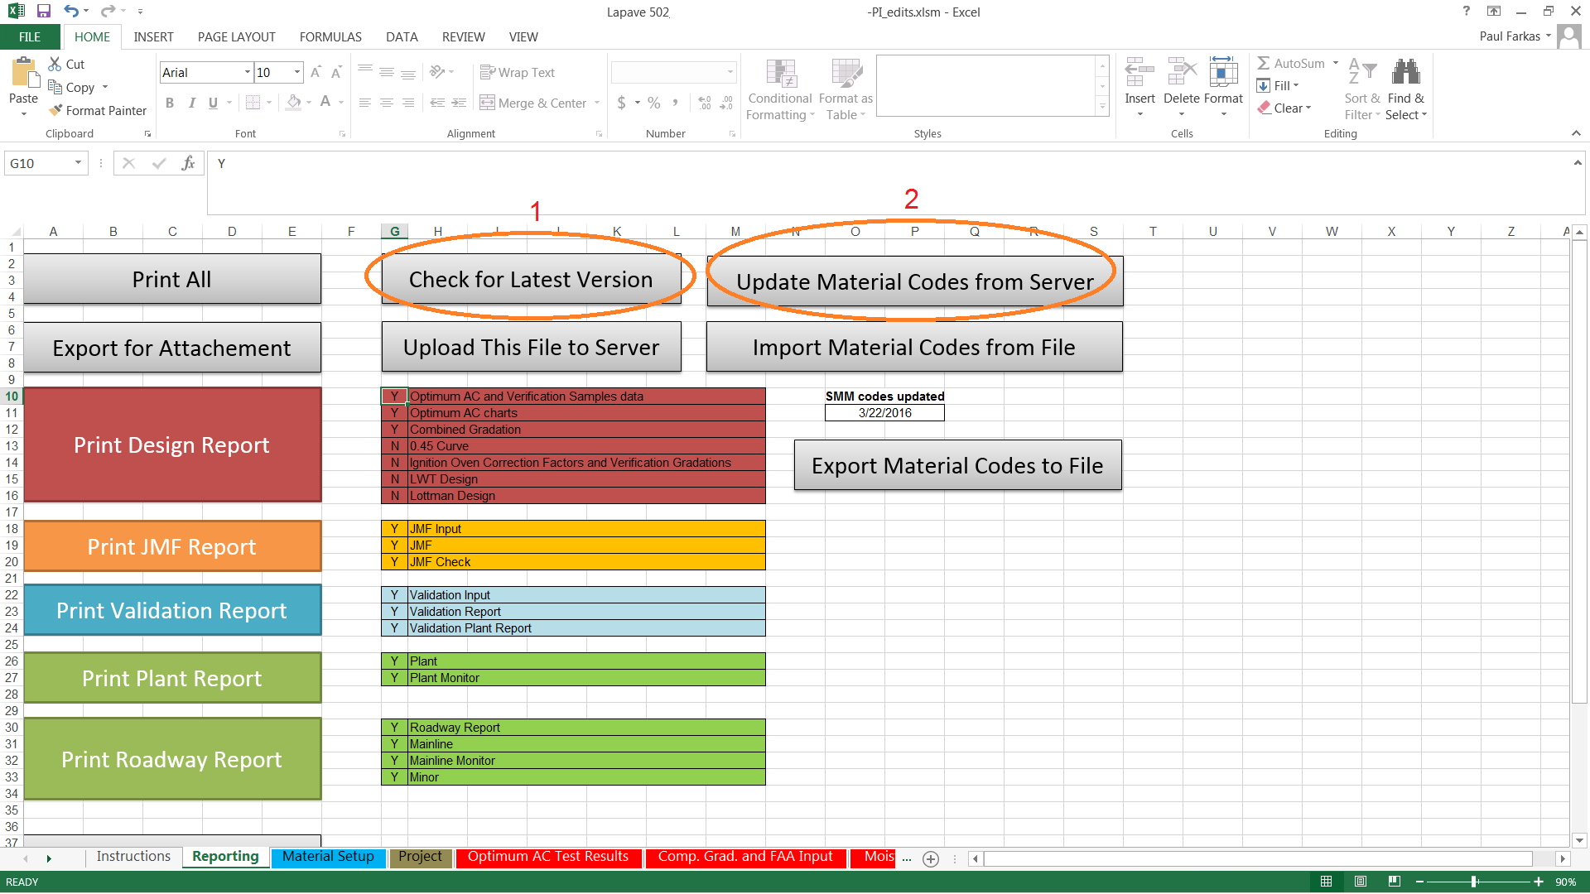
Send the contractor the blank LaPave with the latest Material Codes loaded

Materials Setup
The contractor can create a “Material Setup” that can be exported & imported
Materials that are specific to a contractor can be selected from drop downs. The setup will greatly reduce the selection options as well as speed up the JMF process. Mix additives, AC source & grade, coarse & fine aggregates, and RAP are some of sources that can be contractor specific
Consensus properties as well as gradations for the individual aggregates can be entered. This will auto populate certain fields for the JMF input process
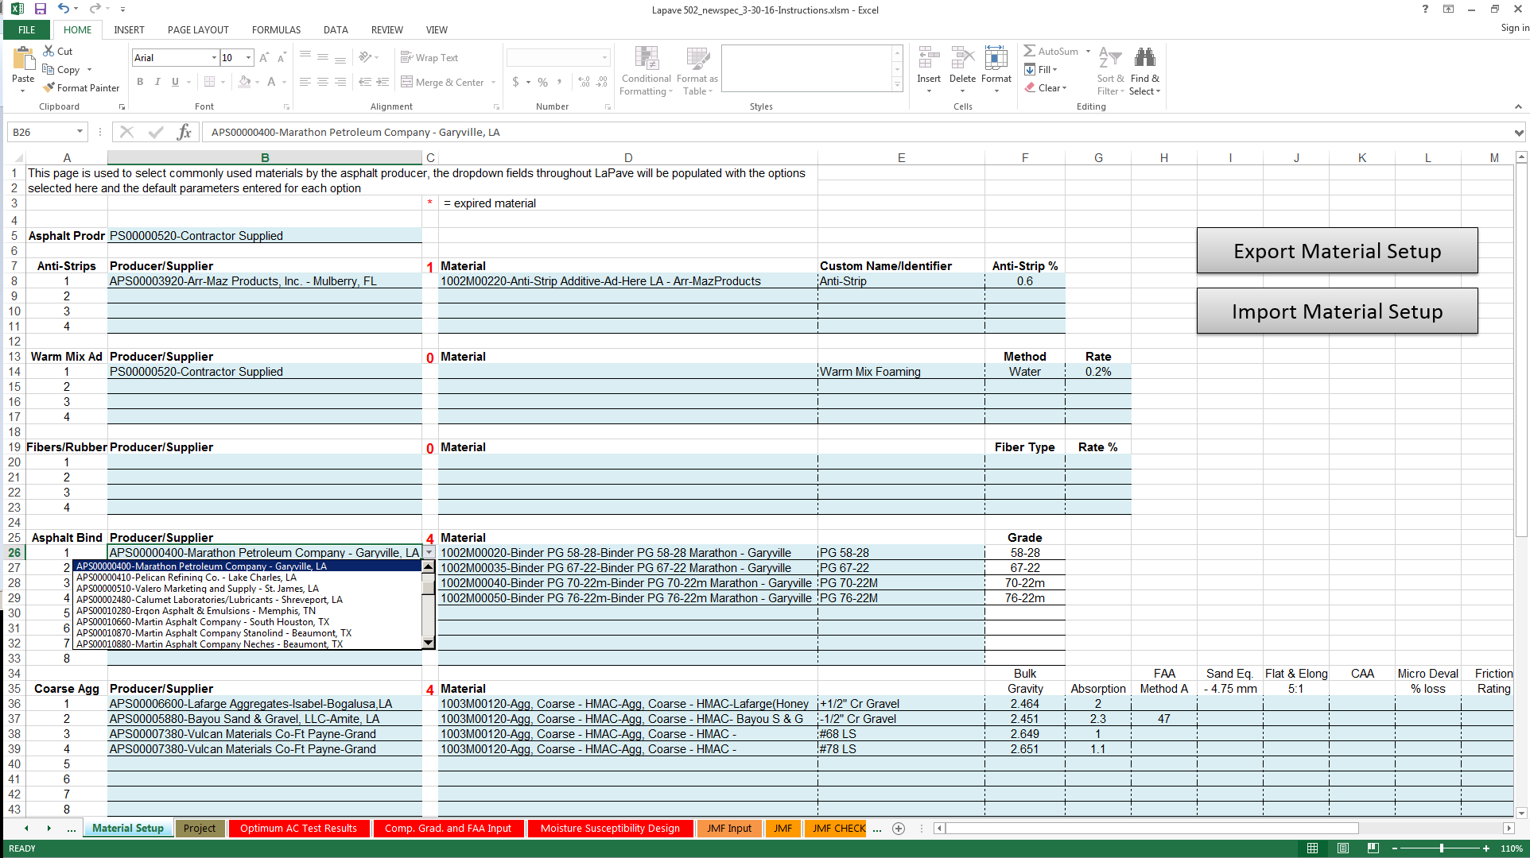

Project Tab
The Project Tab is used to enter project information that can be modified if necessary
- Click the new button to create a new project
- Enter the project number, project name, project engineer, contractor, ADT & ESAL count
- Click the submit button record the entered information. If using the Excel version of LaPave, you must also use the “SAVE” function
- The arrows are used to scroll through the projects that have been entered
If the information for a project needs editing, scroll to that project. Edit the information & click submit. If using the Excel version of LaPave, you must also use the “SAVE” function
If you are on the last entry there will be a “You are on the last record” dialogue box
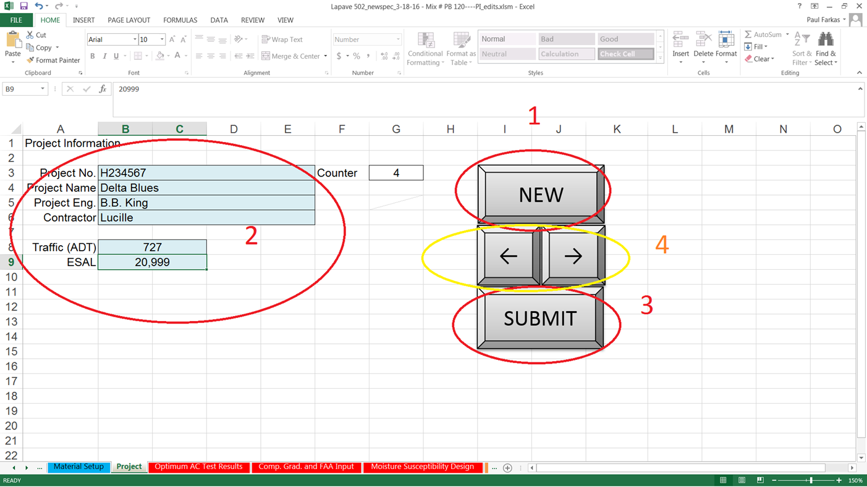

Optimum AC Test Results Tab

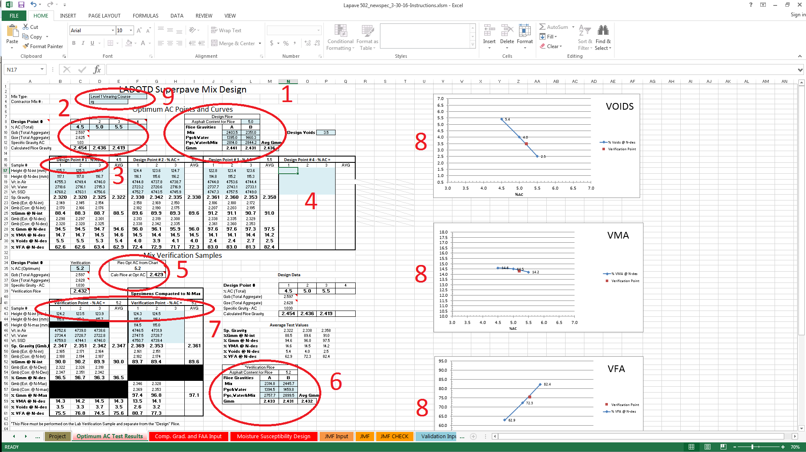
The “Optimum AC Test Results” tab is used to enter design information. The Blue fields are data entry fields.
- One G_{mm} is entered at or near the optimal AC content
- The sheet will calculate the G_{mm} plus and minus 0.5% from the entered G_{mm.}
- A minimum of two gyratory briqs at the three design AC contents are to be made and entered into the top portion of the tab. There is a place for a third briq at each AC content if the designer so chooses.
- There is also a section for a fourth AC content point for use at the option of the designer
- The tab will plot give a suggested AC content that the designer may their discretion. This is based on the design voids entered and the graph fit
- A verification G_{mm} also required as part of the design process
- A minimum of two design and one max brig is required for the verification point. There are places for three of each if the designer chooses to utilize all entries.
- The design information is plotted for Voids, VMA and VFA. The three or four points that form the graph line are the design points. The red point on the graph represents the verification point.
- Mix type entry and Contractor Mix ID

Comp. Grad. And FAA Input
This tab is being covered in two parts
The first will cover individual aggregate gradation, composite gradation, gradation bands and .45 power curve
- The individual aggregate names will be picked up from the JMF input page along with bin percentages. The gradations can be populated one of two ways
  - If the contractor utilizes the Material Setup tab, gradation values will auto populate if they were set up.
  - They can be manually entered if “Other” is used on the “Aggr. Class” dropdown on the “JMF Input” tab. After manually entering the gradation, the “Aggr. Class” can be changed to either “Coarse” or “Fine”
- Gradations for the individual aggregates
- Composite gradation of the mix
- Gradation band for the Nominal Aggregate Size
- FAA values and bin percentages are auto populated from the “JMF Input” tab
- .45 power curve
____________________________________________________________________________________________________________________
The second part of the “Comp. Grad. and FAA Input” tab is about mix correction factors.
This establishes gradations of lab design mixes after going through the ignition furnace as well as the difference between the known AC content compared to the scale to scale calculated AC content to create an AC correction factor.
There should be a minimum of two ignition furnace extractions, which are averaged, to determine correction.
- Weight for the empty burn basket is entered. The weight of the basket and mix is entered before and after the furnace extraction. The initial weight of the recovered aggregate as well as the dried weight after washing over the #200 sieve.
- The gradation weights are entered.
- The weight of the + #4 crushed aggregate is entered to calculate the percent crushed.
- If the difference between the two correction factors is greater than 0.15, two more furnace extractions should be performed.
- A gradation comparison is given for the after burn gradation vs composite gradation.
- The calculated correction factor that will be used on the JMF.
- Entry for the second furnace extraction and gradation.
Repeat for the third and four if the difference between the first and second burns are greater than 0.15

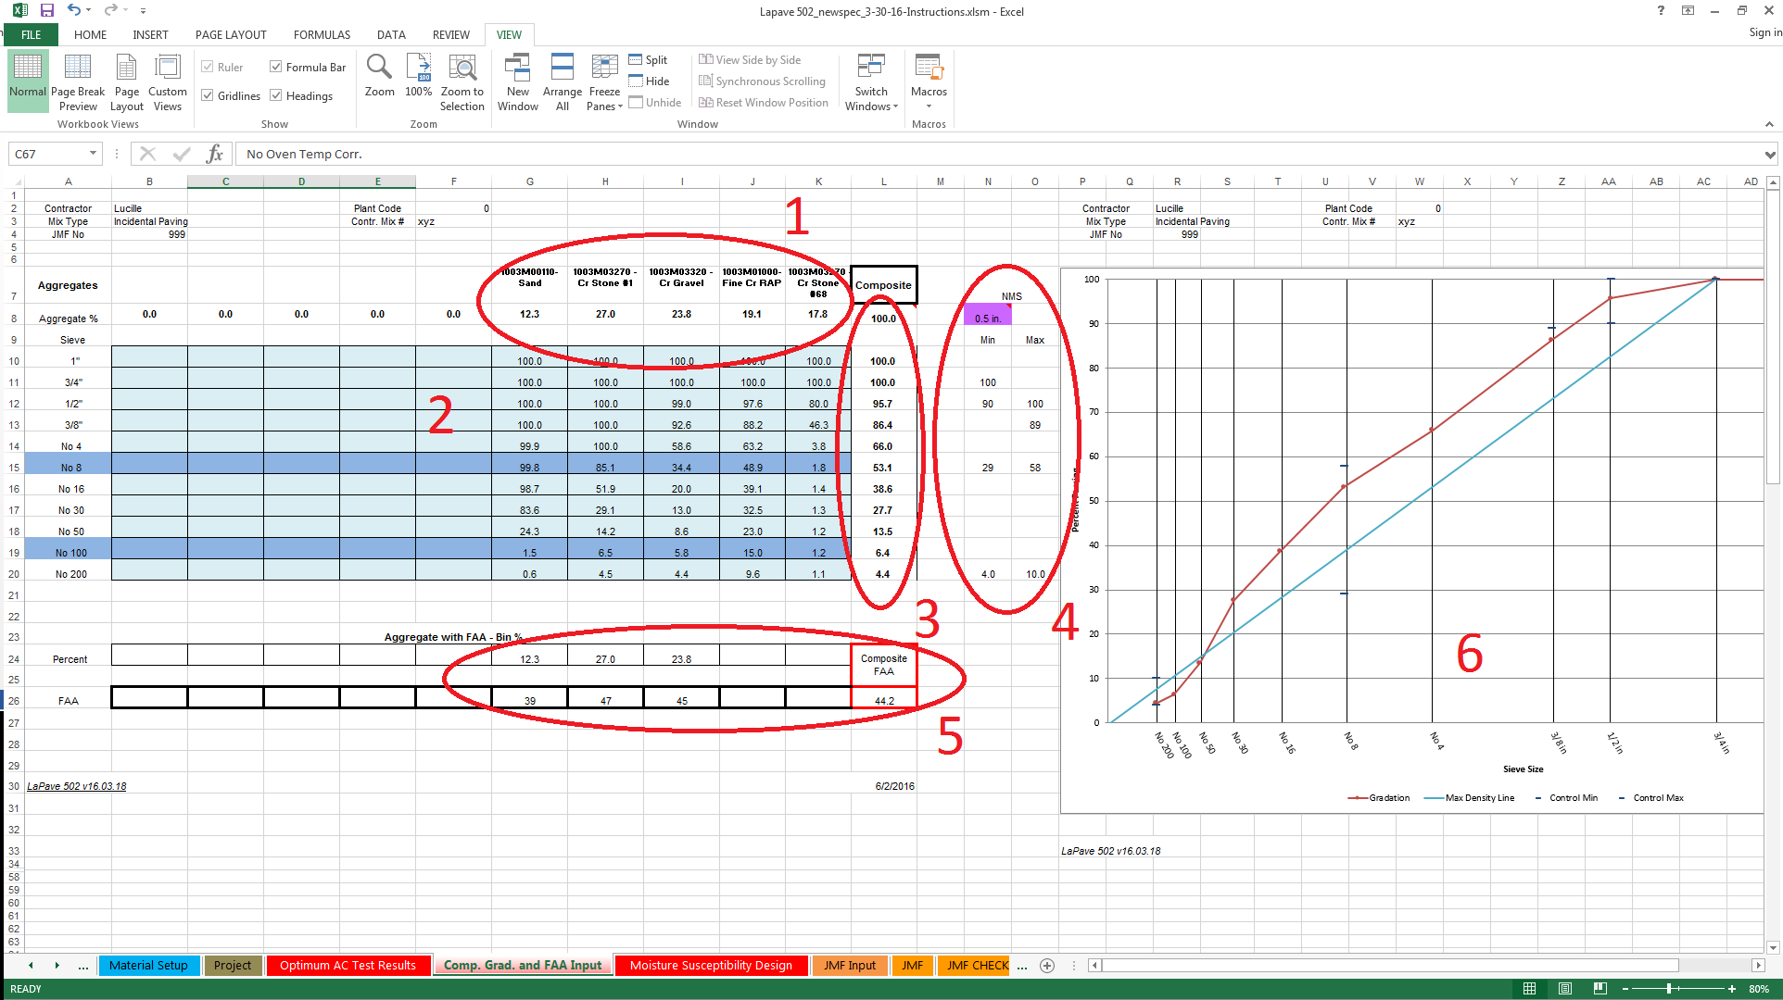

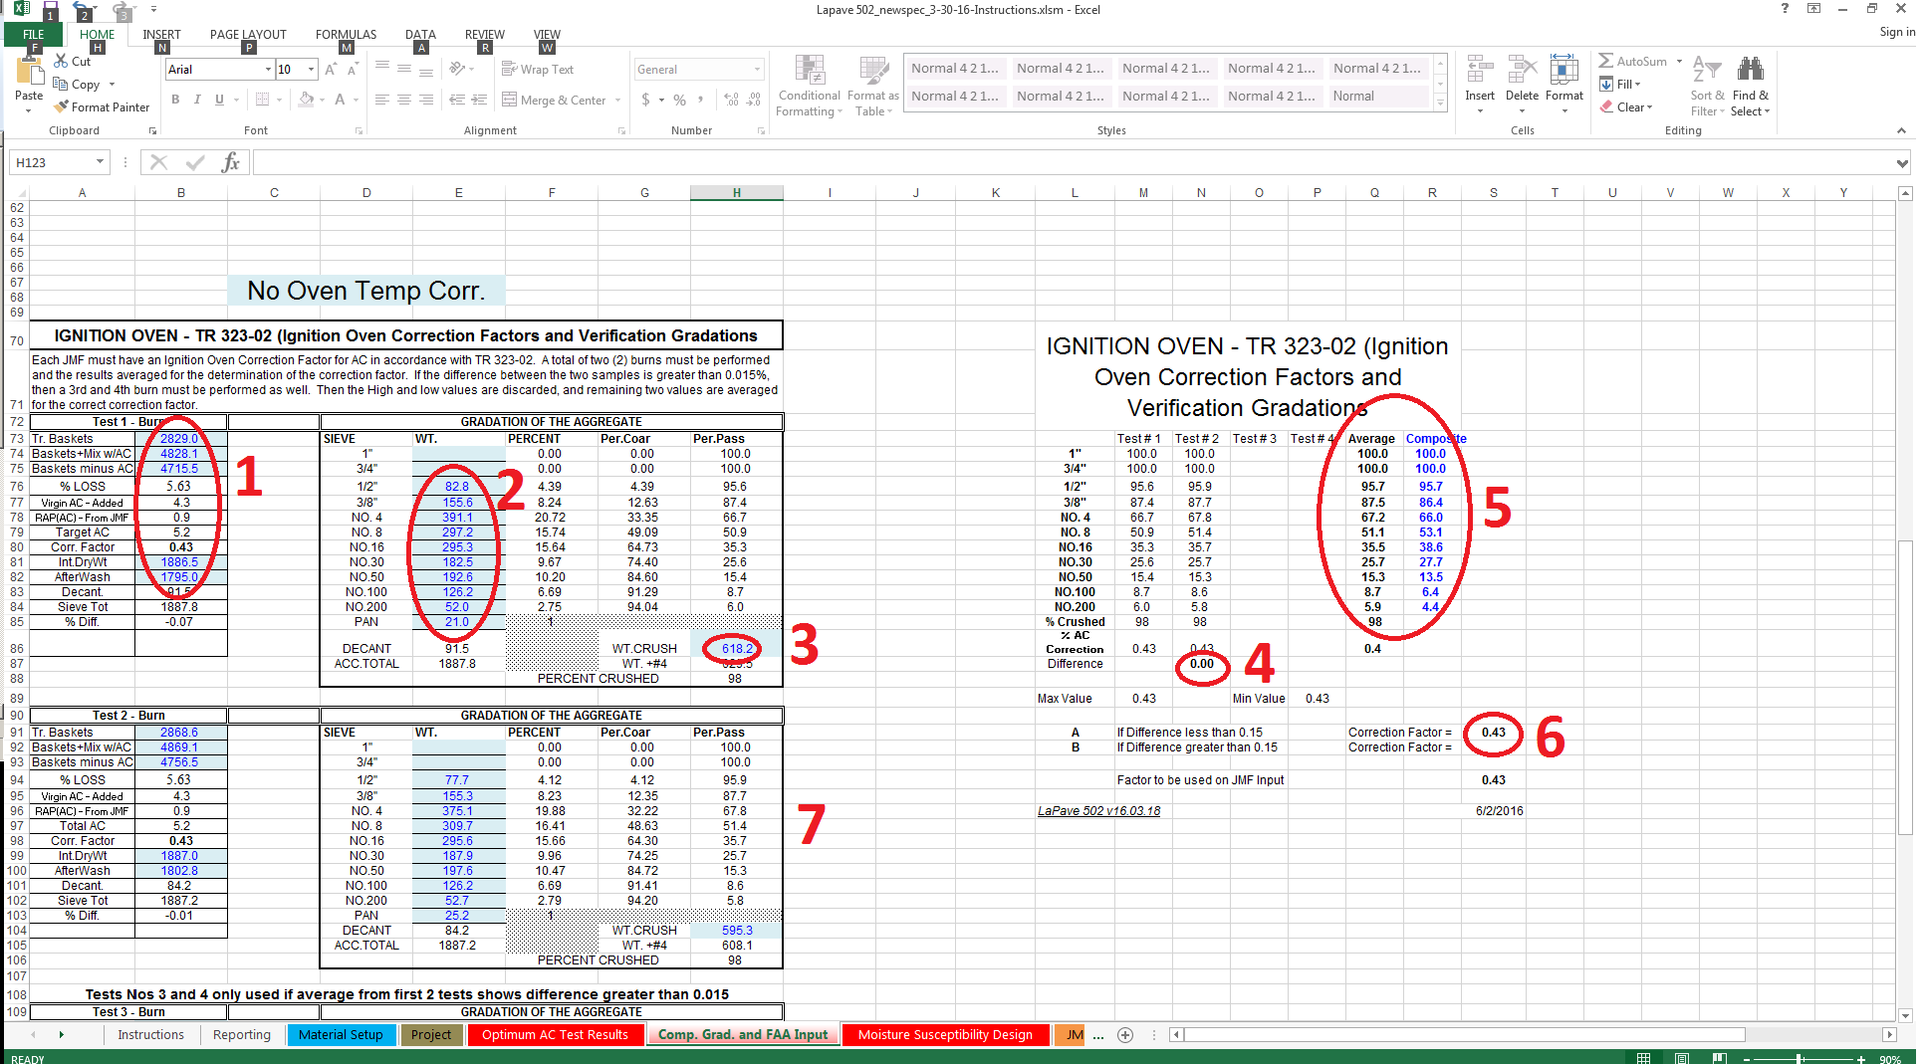

Moisture Susceptibility Design
This will be covered in two parts.
LWT AASHTO T 324 – Can be used for all mixes. Required for all mixes under traffic.
- There is an entry for the LWT for design and one for plant run mix that is part of the validation process
- The date sampled for both design and validation
- The G_{mm} submitted with the design
- The G_{mm} determined from the validation that is automatically pulled from the JMF.
- Air, water, and SSD weights are entered to determined void content of the gyratory samples
- Paired samples and average voids of the pair.
- If a dual wheel tracker or a second set of samples are tested this will be utilized.
- Temperature test was performed
- The number of passes on the LWT correlating to the mix type and specification requirements
- Pass / Fail dropdown
- The rut depth at the corresponding pass
- If a dual wheel tracker or a second set of samples are tested this will be utilized
TSR TR 322 / AASHTO T 283 – Tensile Strength Ratio – This can be used for minor mixes at the option of the contractor.
Like the LWT, this test will need to be performed on the lab design as well as plant run mix.
- Date mix was sampled
- Weights entered to determine air voids. Sort the specimens into two sets of three so that the average percent air voids of the two sets are as close to equal as possible
- Enter after vacuum SSD and in water weights to calculate percent saturation
- Enter two diameter measurements per the testing procedure
- Enter three thickness measurements per the testing procedure
- Enter the dial reading from the loading apparatus
- Enter the maximum load from the conversion table for the loading apparatus

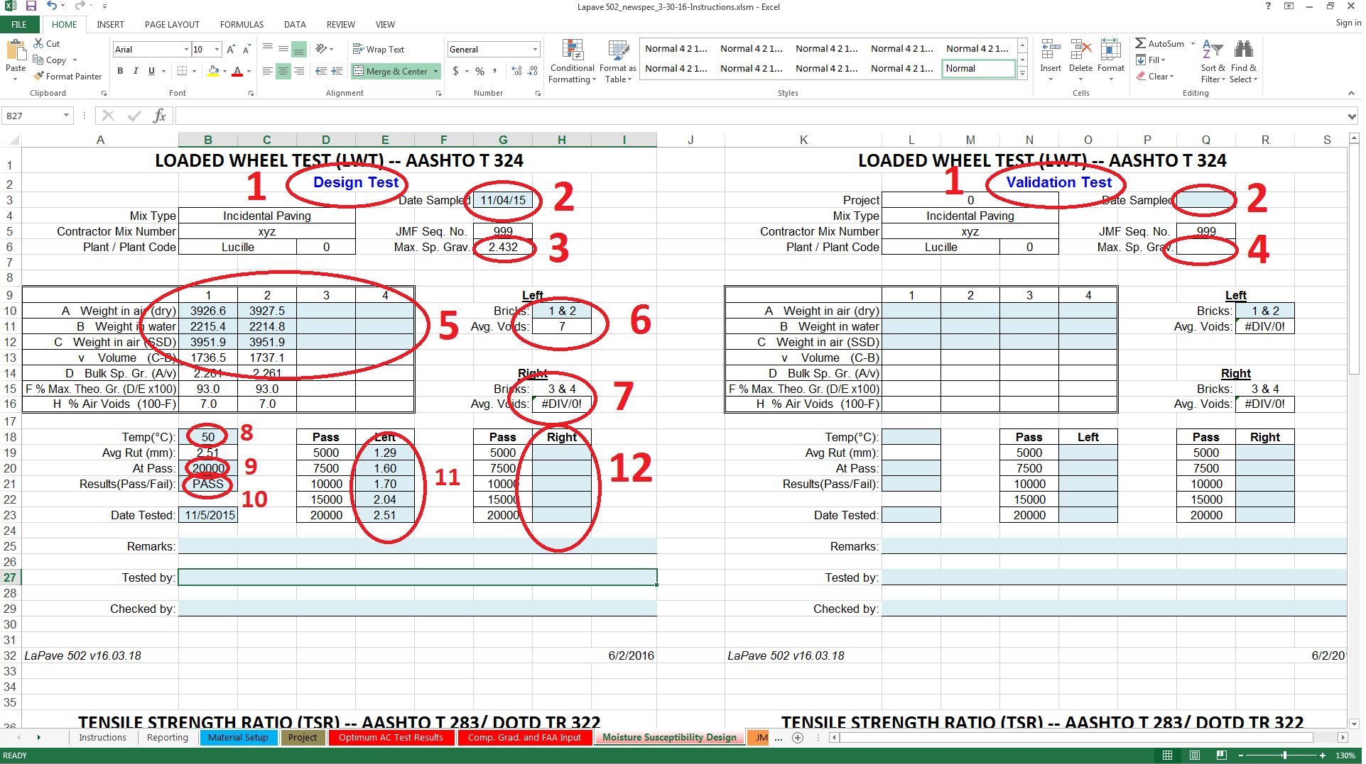

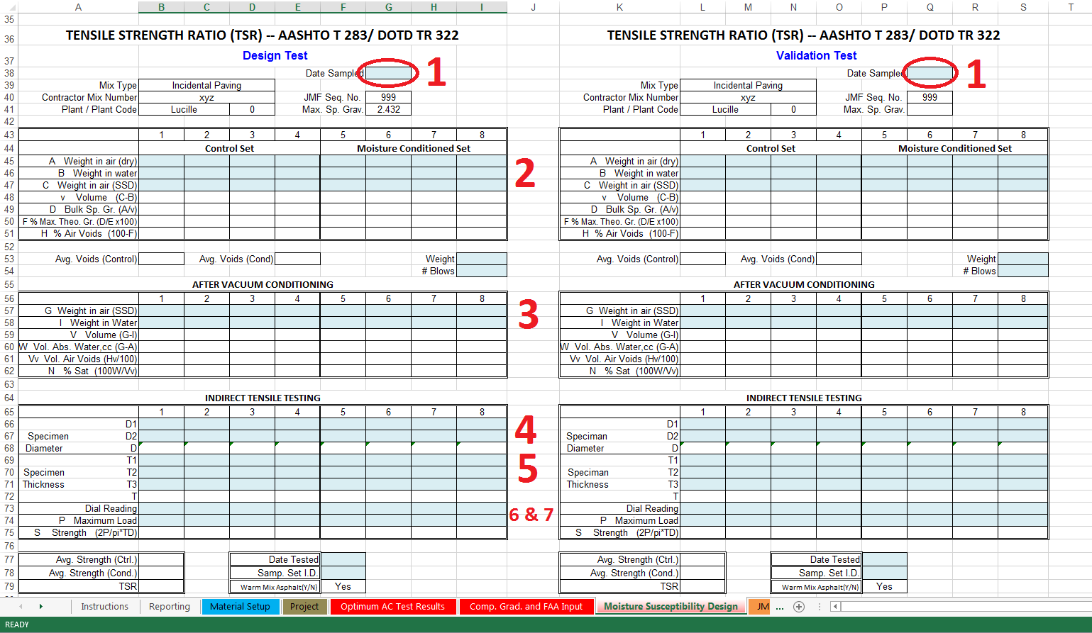

JMF Input
The JMF Input page is a combination of dropdown choices and manual entries. The version with the “Material Setup” tab will have more dropdown choices.
- The header information is completed with a combination of dropdowns and manual data entry.
  - Project No. – Information entered in the “Project” tab will appear in a dropdown. You may have to scroll up for the entered projects to be visible. Project Name, Project Eng. And Contractor will auto fill when the project number is chosen.
  - Contr. Mix # - Manual input
  - Mix Code – Dropdown for either English or Metric. Hopefully there are very few metric projects on the shelfs
  - SMM P/S – Auto populate from the “Material Setup” tab cell B5
  - JMF No – Manual input
  - Design Level – Dropdown
  - Use – Dropdown
  - Plant type – Dropdown
  - Nom Agg Size – Dropdown
  - ADT – Auto populate from Project No. choice
  - Production Rate – Manual entry
  - Mix Temp – Manual entry
  - AC Corr Factor – Auto populate from the “Comp. Grad. and FAA input” tab
  - ESAL – Auto populate from Project No. choice
  - Adj Fac – Calculated from the design G_{mm} and then from the validated G_{mm} after validation
  - SMM ID – Created from GET SMM ID
  - Date – Manual input
  - Design LWT Rut – Auto populate from the “Moisture Susceptibility Design” tab
  - No. Passes - Auto populate from the “Moisture Susceptibility Design” tab

- The Aggregate Type and Consensus section of the “JMF Input” tab can be completed manually in older versions of LaPave or as a combination of dropdown and manual entry in the version of LaPave with the “Material Setup” tab
  - For versions of LaPave with the “Material Setup” tab, choose the “Aggr Class” first. Aggregate Type has a dropdown to choose each aggregate for a JMF. The P/S Code, Bulk Gravity, Absorption, FAA, Sand Eq., and Flat & Elong %5:1 will auto populate from information entered on the “Material Setup” tab. Older versions of LaPave, all the above properties will have to be entered.
  - The “%” of aggregate in a manual entry.
  - % Ret No. 8 and % Ret No. 4 auto populates from the “Comp. Grad. and FAA Input” tab
  - Aggr. Class has dropdowns for Coarse, Fine, RAP and Other. If RAP is chosen, it will auto populate the “%” based on the data entered in the section containing Rap 1 and Rap 2. Choosing Other will allow manual entry of the gradation for that particular aggregate on the “Comp. Grad. and FAA Input” tab.

- Material – In older versions of LaPave this is a manual entry. In the LaPave with the “Material Setup” the Asphalt and Anti-strip can be chosen from the dropdown from each. The Asphalt Content from RAP is auto populated from the data entered in Rap 1 and Rap 2.
- Warm Mix – Warm Mix – Yes/No dropdown, Method – Water, Chemical or None dropdown, Rate – manual entry, If Chemical – Brand Name – manual entry
- Draindown Control – Cellulose Fiber, Mineral Fiber, Crumb Rubber, and None from the dropdown
- %Crushed, Comp. Temp, and SCB Jc are manual entries
- Rap 1 and Rap 2 - %Mix Rap Total and % AC in RAP are manual entries
- Cold Feed and Avg Oven Extract – Auto Populate from the Comp. Grad. and FAA Input tab
- Validated Results – Populated and tolerances applied from the “JMF” tab
- IMPORT button – Import all the JMF information from another LaPave file

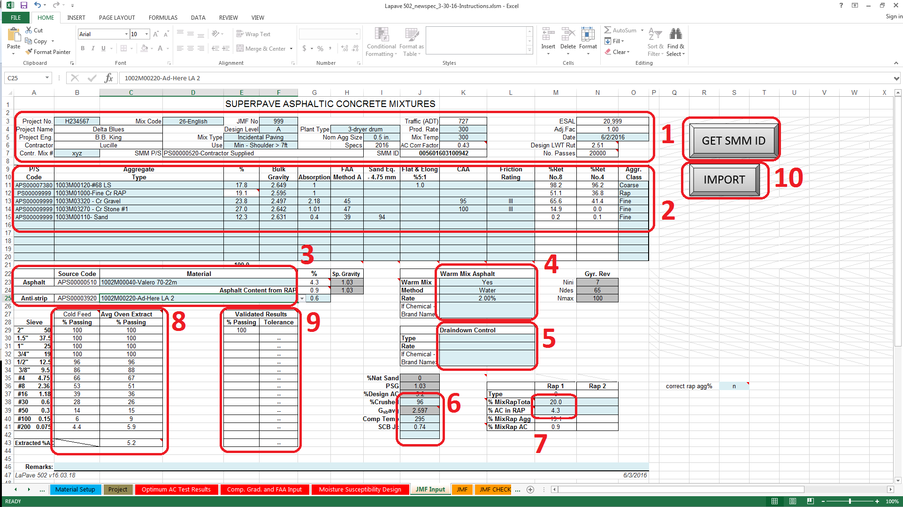

JMF
For the most part, the “JMF” tab auto populates. The signature area has some input as well as the Remarks section.
- The header section auto populates based on the project selected and the design information input on the “JMF Input” tab
- The aggregates, bin percentages, properties and source codes auto populate from the “JMF Input” tab.
- Composite averages are calculated and shown on the “JMF” tab
- Asphalt Cement and Additives are auto populated from the “JMF Input” tab
- LWT and SCB Jc value are displayed in this section

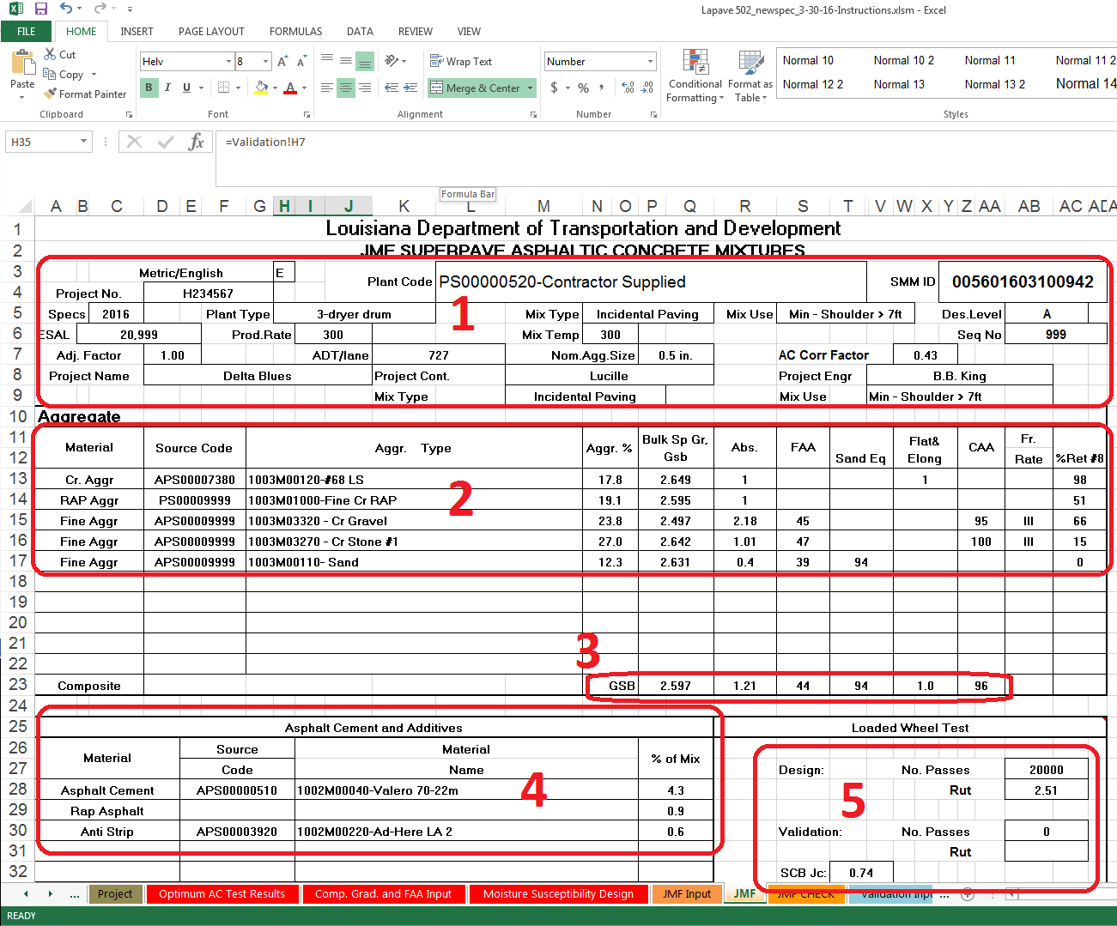

- JMF values from the mix design
- JMF average values from the validation
- The standard deviation of each parameter from validation data
- PWL from the validation data
- Specification limits based on validation averages
- Submittal and approval area
- Remarks

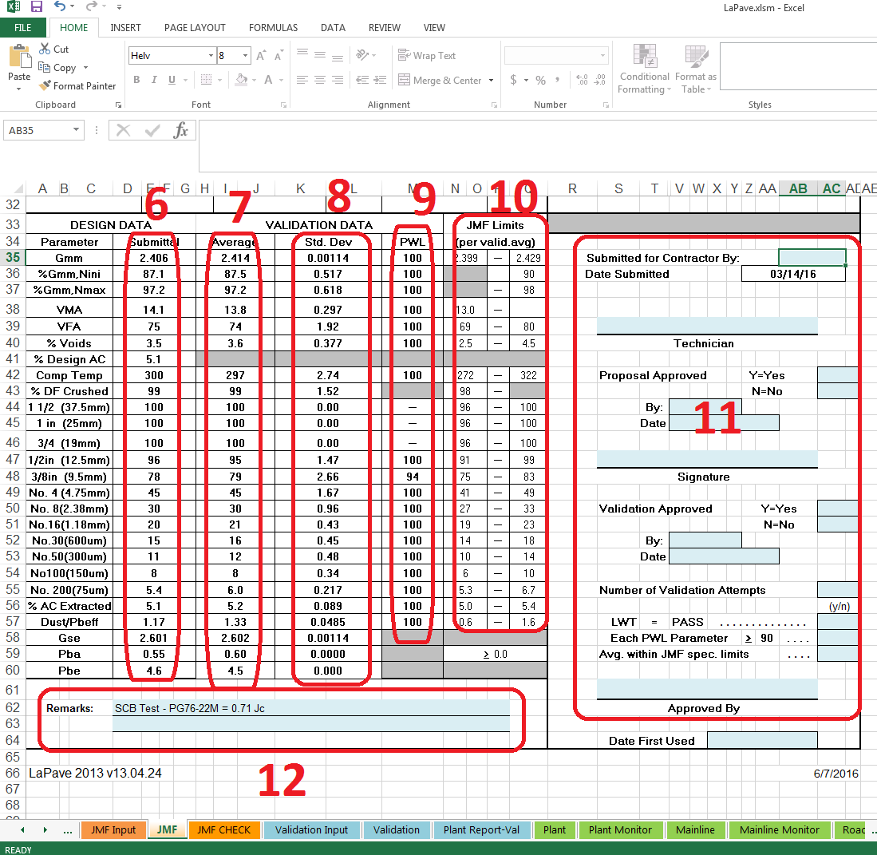

JMF CHECK
- Header area is auto populated from the “JMF Input” tab
- The aggregate section is auto populated from the “JMF Input” tab with the Apparent Gravity calculated on this sheet.
- Percent Virgin AC, Percent RAP AC and anti-strip rate. This is auto populated from the “JMF Input” tab.
- Average Volumetrics for the most part pulls from the Optimum AC Test Results. VFA is calculated on optimum voids (3.5 for most mixes) not the voids of the design gyratory briqs.
- Shows the composite gradation from the cold feeds, the furnace extraction gradation & the average gradation from the validation with tolerances.
- Warm mix information pulled from the “JMF Input” tab
- Drainwdown Control information pulled from the “JMF Input” tab
- Information for up to two RAP cold feeds. The overall percentage of RAP including AC, the residual %AC of the RAP, the aggregate credit to the mix and the %AC credit to the mix.
- The average rut from the LWT is pulled from the “Moisture Susceptibility Design” tab
- TSR information if this option is used for minor mixes is pulled from the “Moisture Susceptibility Design” tab
- The N_{ini}, N_{des}, and N_{max} gyrations are pulled from the “JMF Input” tab. The type and design level of the mix chosen on the “JMF Input” tab determines these numbers

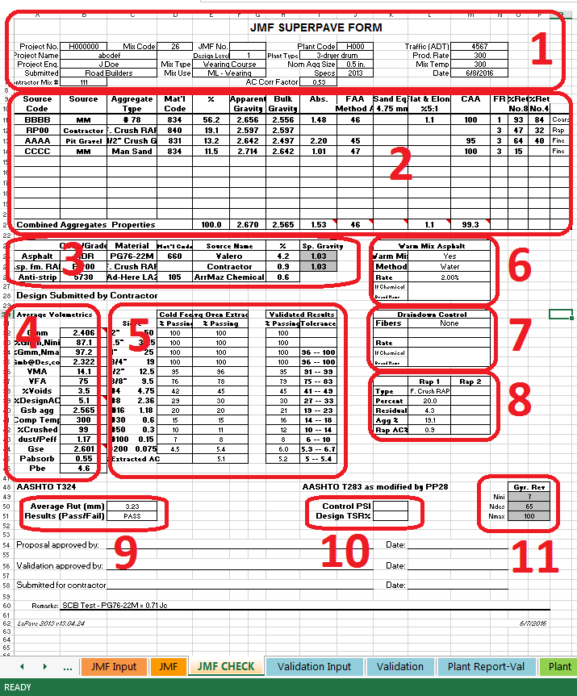

Validation Input
- The header information is a combination of auto population and user input.
  - Proj. No. – Choose a project from the drop down that was entered on the “Project” tab. Proj. Name will auto populate from information entered on the “Project Tab”
  - Lot Size – The tonnage in the Validation Lot. Between 1000 and 2000 tons.
  - No. Sublots - Populated from the number of Rice gravities entered
  - SMM P/S – Populated from the “JMF Input” tab which is pulled from the “Material Setup” tab
  - JMF No. – Populated from the “JMF Input” tab
  - Start & End Date – Manual Input
  - %AC – Populated from the “JMF Input” tab
  - Design Level – Populated from the “JMF Input” tab
  - G_{sb} – Composite bulk gravity of aggregates auto populated from the “JMF CHECK” tab
  - Mix Type & Mix Use – Drop down choices that should correlate to the design level choices made on the “JMF Input” tab for the same fields
  - P_{s} – Percent stone (aggregate) = 100 - %AC
  - SMM ID – Generated and pulled from the “JMF Input” tab
  - AC Corr Factor – Is determined on the “Comp. Grad. and FAA Input” tab

- Paired G_{mm} test for the five sublots
- Individual G_{mm} results
- Air, Water, SSD weights and heights for N_{des} and N_{max} briqs
- The percent virgin AC metered rate, compaction temperature of the sample, tonnage in the validation lot the sample was taken, Mix Temp in the haul truck, and the antistrip rate
- Scale to scale %AC data entry, aggregate for gradation weights and weight of crushed aggregate
- Gradation weights with decant loss calculation and percent passing calculation
- Repeat for the rest of the validation sublots
- Roadway Density Cores – Under the 2016 spec, the contractor or DOTD make take informational cores to check for density. The acceptance cores will come from the 37,500’ roadway lot on the project.

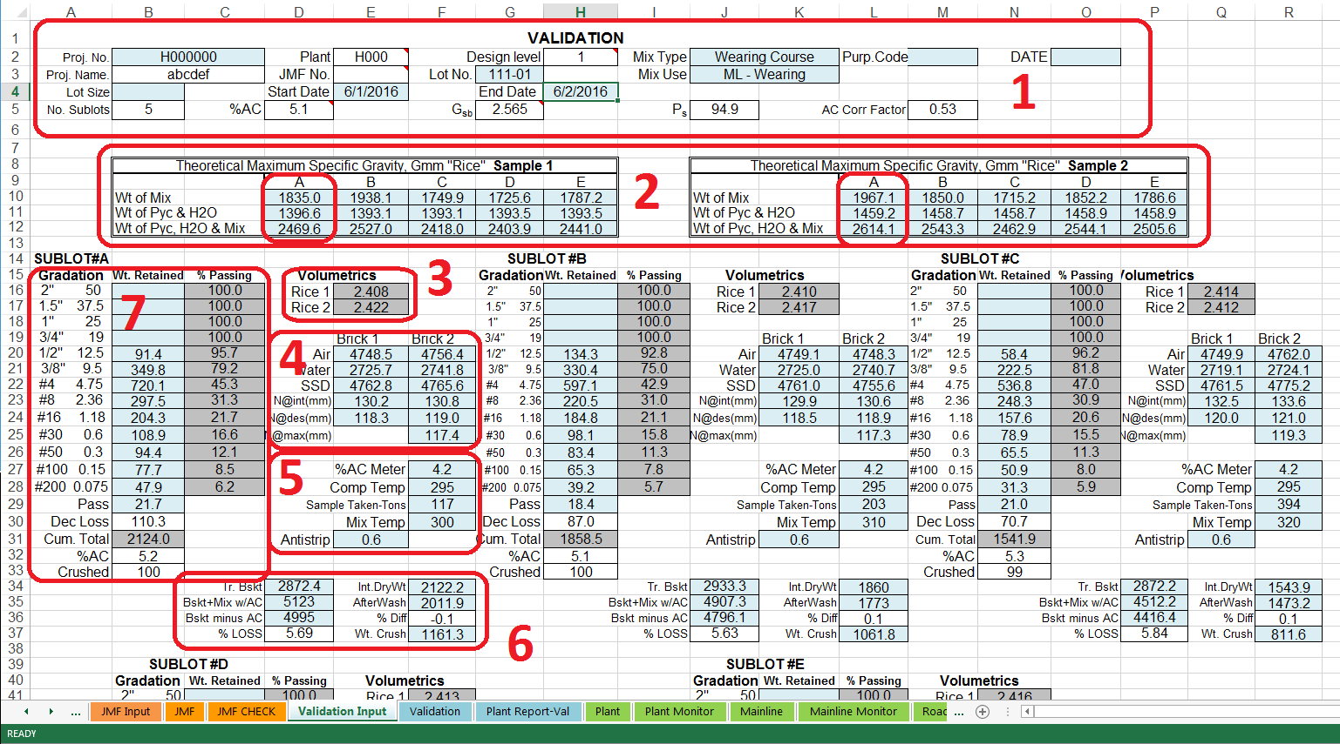

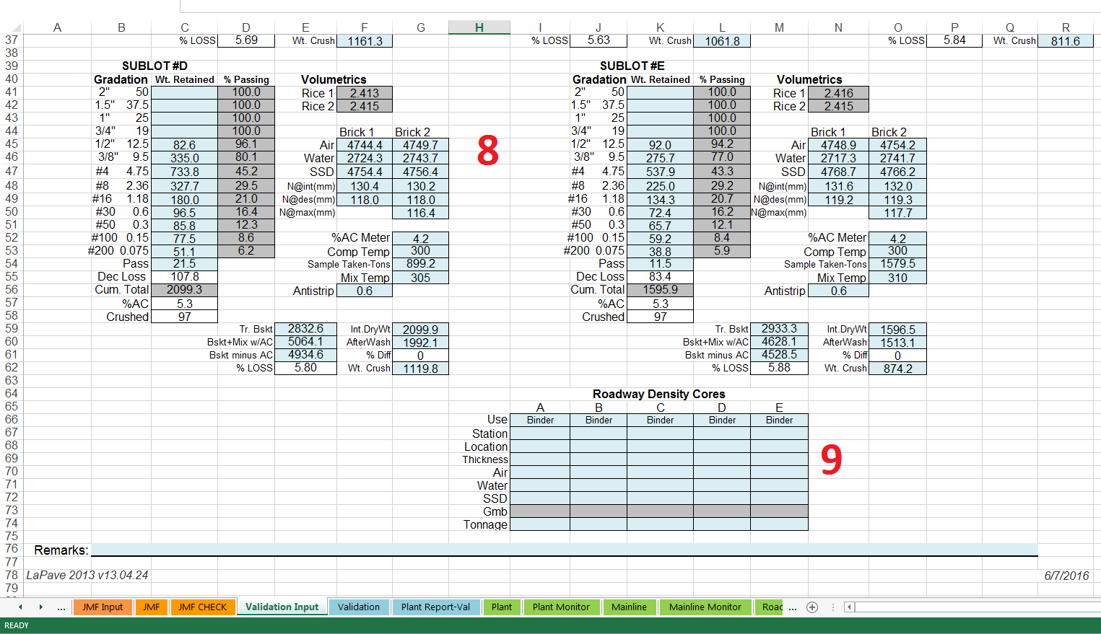

Validation
- Summary of the 5 sublots test for the validation
- The mean of the 5 sublot test that become the target values for the JMF
- The standard deviation of the test results
- PWL information
- Whether or not the parameter meets specifications
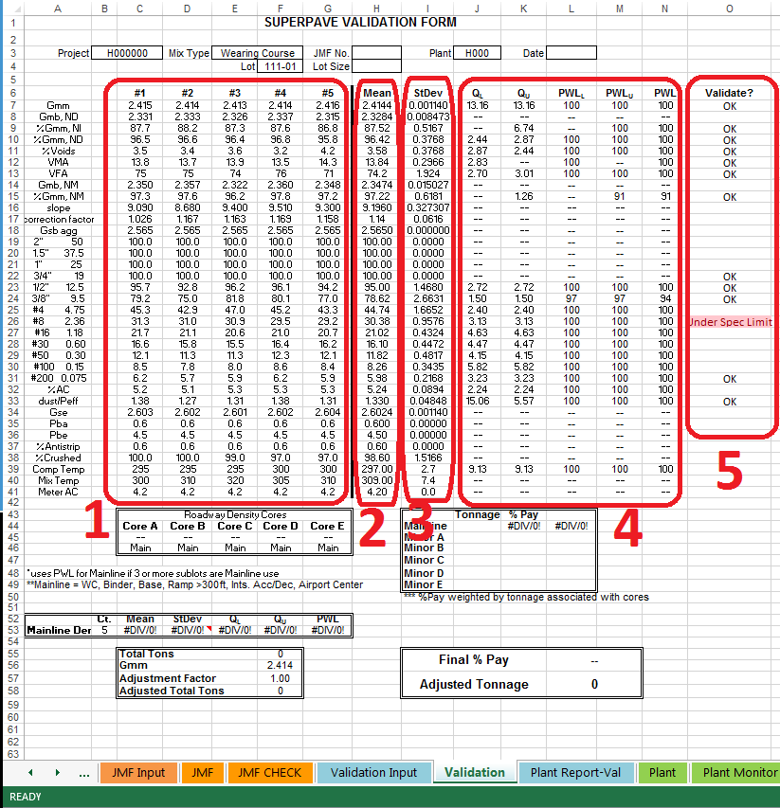

Plant Report – Val
The Plant Report – Val - A summary sheet of the validation that contains some of the raw data.

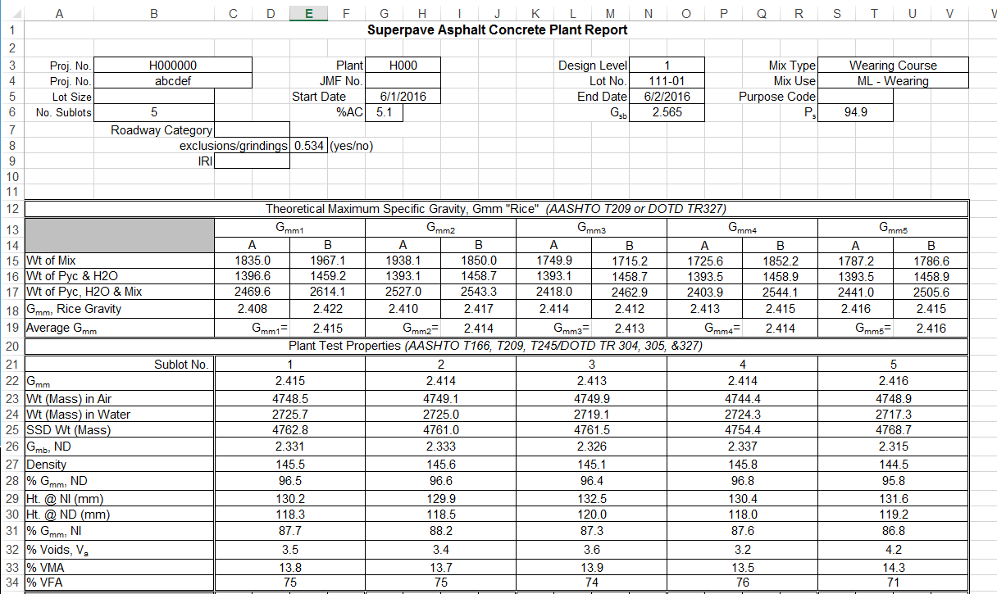

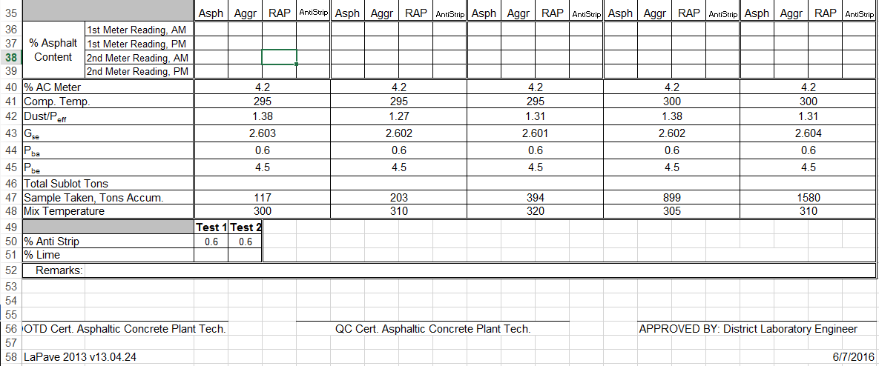

Plant
This tab is for inputting P-Lot test data and monitoring the rolling averages of plant data
Blue fields are for input
- “NEW” button initiates a new test set for a P-Lot. If the time line and daily tonnage requires multiple test in the same sublot, the P-Lot No. nomenclature can be modified by adding A, B, C….etc to the end of the lot number. It will be necessary to click “NEW” for each test set.
- In the dropdown, choose either Contractor (Acceptance), DOTD (Verification), Contractor (QC only)
- In the drop down, choose whether to use “No Oven Temp Corr.”, or “With Oven Temp Corr.”
- In the drop down, choose whether the validation data is included in the “Rolling 5” data calculation.
- Enter date(s) and P-Lot number. (The JMF sequence number plus the P-Lot, ex 101-001)
- Enter the tonnage at which the sample was taken
- Enter weights for moisture content of the loose mix
- Enter the Metered AC (Virgin AC metered into the mix), the lab compaction temperature, the mix temperature in the haul truck, and the rate of anti-strip check
- G_{mm} data entry
- Furnace extraction data entry
- N_{des} briq data entry.
- For every 5th P-Lot, a N_{max} briq needs to be tested. After the “Submit” (#16 below) button has be clicked, the N_{des} data can be cleared and the N_{max} data can be entered. The submit button will need to be clicked again.
- The recovered aggregate from the furnace extraction and the after wash weight of the aggregate.
- Gradation weights
- Weight of the crushed aggregate
- The “Submit” button. This button has to be clicked to submit the entered data to the tables in the different Plant Summary tabs. Data can be edited or updated, but the “Submit” button will need to be clicked again to update the tables.
- Weights of LWT briqs for calculating the void content.
- Depending on if one pair of LWT briqs (single wheel tracker) or two pair (double wheel tracker) are made, this drop down chooses the pairing up to match the voids. This data can be added after the P-Lot data is entered. The “Scroll” (#21) and “Submit” (#16) buttons will help in navigating between P-Lots.
- Data and parameter entry for LWT testing.
- The rut depth for the correlating number of wheel passes.
- The “Scroll” button displays data from previously entered P-Lots. Using the dropdown (#2), the three data entry types can be viewed & edited/updated by clicking the “Submit” (#16) button.
- The “Print” button prints the data entry numbers and the rolling averages from the “Plant” tab.
- The tonnage for the P-Lot. This can be entered after the P-Lot is closed. The “Scroll” and “Submit” buttons can be helpful here.
- Append buttons. Data will be “Pushed” from this LaPave file to another LaPave file. This is helpful in sharing data between the contractor and DOTD. One of the three types of data can be pushed or all three can be pushed together to another LaPave file.
REMEMBER TO ALWAYS USE THE SAVE FUNCTION OF EXCEL. THE “SUBMIT” BUTTON DOES NOT SAVE THE DATA, IT ONLY PUTS IT IN THE DATA TABLES

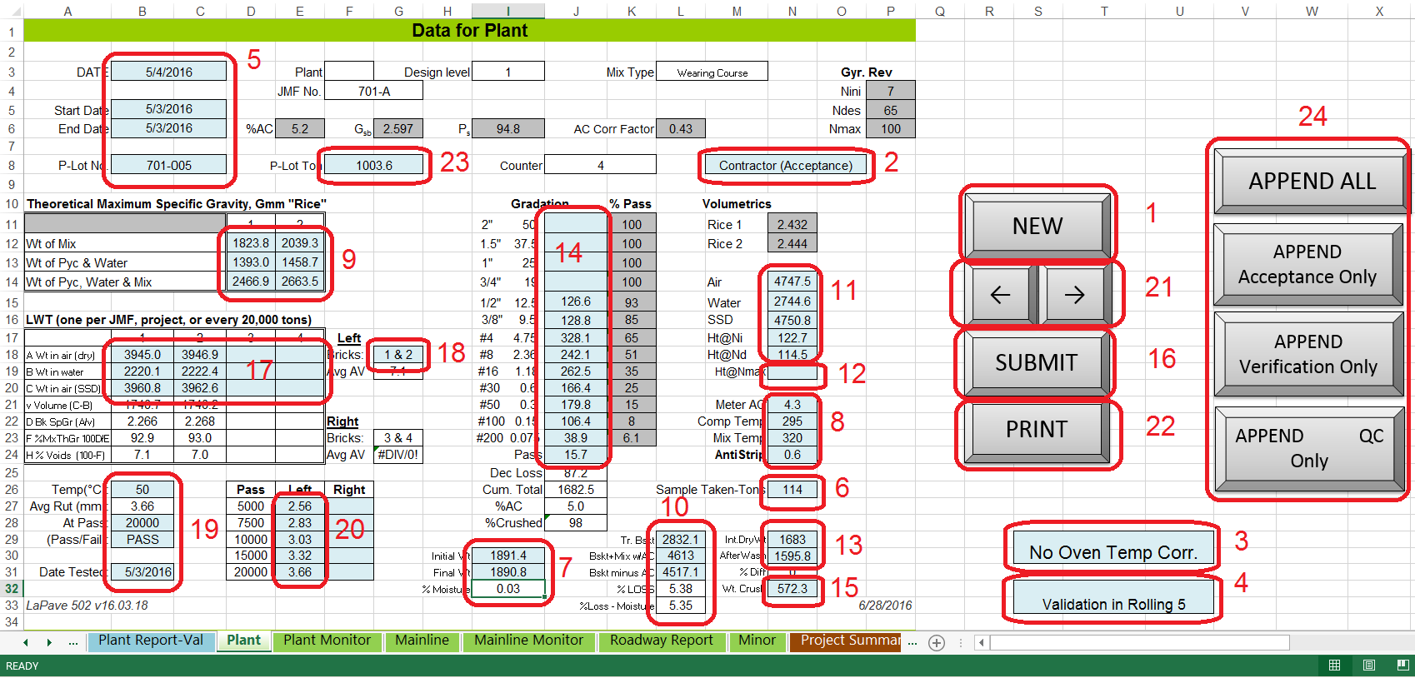
There is no data entry for the “Rolling Average.”
The following screen shot below displays the “Rolling Averages”. By using the “Scroll” (#21) button above, the “Rolling Average” can be moved within the recorded data.
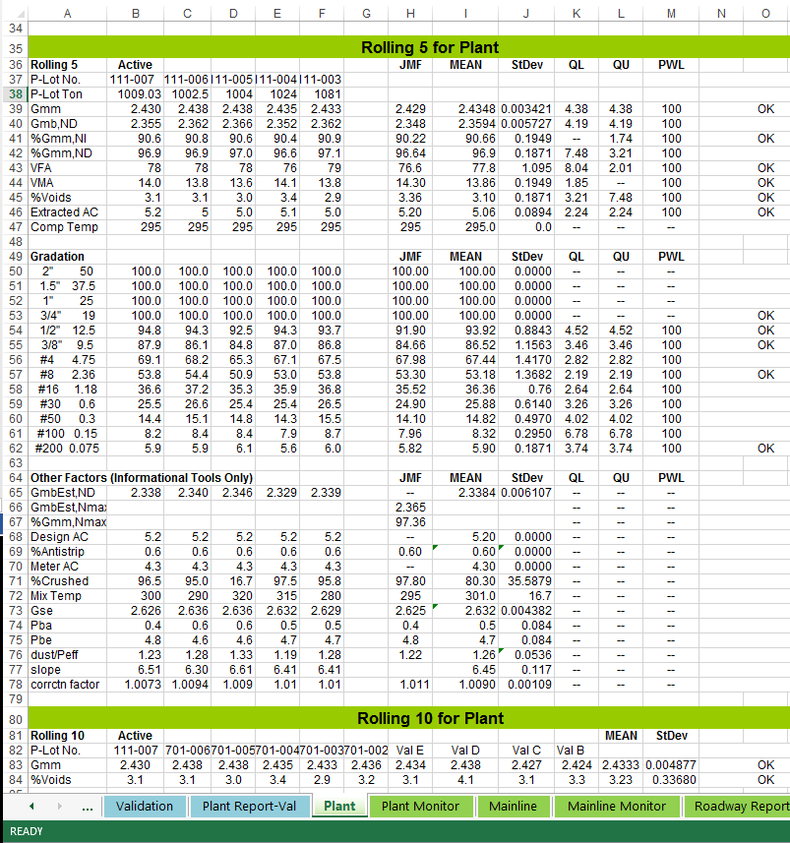

Plant Monitor

This tab will display F & t analysis for plant data.

Mainline

- Click “NEW” to start a new roadway lot
- Choose a project from the dropdown. This associates the cores to the project. (Remember, it is possible to have the same lot number on multiple projects. Each project starts with roadway lot #1.)
- Enter Date, from dropdown choose whether method 1 or 2, and enter Roadway Lot #. Depending on choice in #4, it will display “Mainline Lot #” or “Minor Lot #”.
- Choosing the mix use in this dropdown, will trigger between Mainline or Minor mix calculations.
- Enter the beginning date and ending date of the mix placement for the lot. This can changed or edited later, using the Scroll (#12) and Submit (#11) buttons.
- The tons for the sublot can be entered in just one block of each sublot or for each core.
- The mix use and location are dropdown choices with the rest of the areas typable entries. The random number entry is for the transverse location. The station number represents the longitudinal location. Each sublot has three acceptance core entries.
- The verification core has the same data fields as the acceptance cores.
- The G_{mm} check from a randomly chosen core from the lot is entered here. If the first one fails to verify then two more roadway cores are randomly selected and the G_{mm} data is entered here.
- To override the default G_{mm}, enter the G_{mm} to be used here.
- After the data for the current session has been entered, click the submit button. This will put the data in the summary tables.
- The “APPEND” button will “PUSH” any added data from this tab to another LaPave file. The intended use of this feature is for data transfer between the contractor and DOTD, the inspector updating the LaPave file at district, or updating files over a network. After clicking this button, the user will be prompted what file to append to. The user will have to navigate to where the second file is to send the new date to. The file can be located on the same computer, a USB stick or over a network.
- Resolution core information is entered in this area.
- G_{mm} data derived from resolution cores is entered here.
- The print button will print both the top and bottom of the “Mainline” tab.
REMEMBER TO ALWAYS USE THE SAVE FUNCTION OF EXCEL. THE “SUBMIT” BUTTON DOES NOT SAVE THE DATA, IT ONLY PUTS IT IN THE DATA TABLES

The second screen shot is the bottom portion of the “Mainline” tab with the density and statistical data.

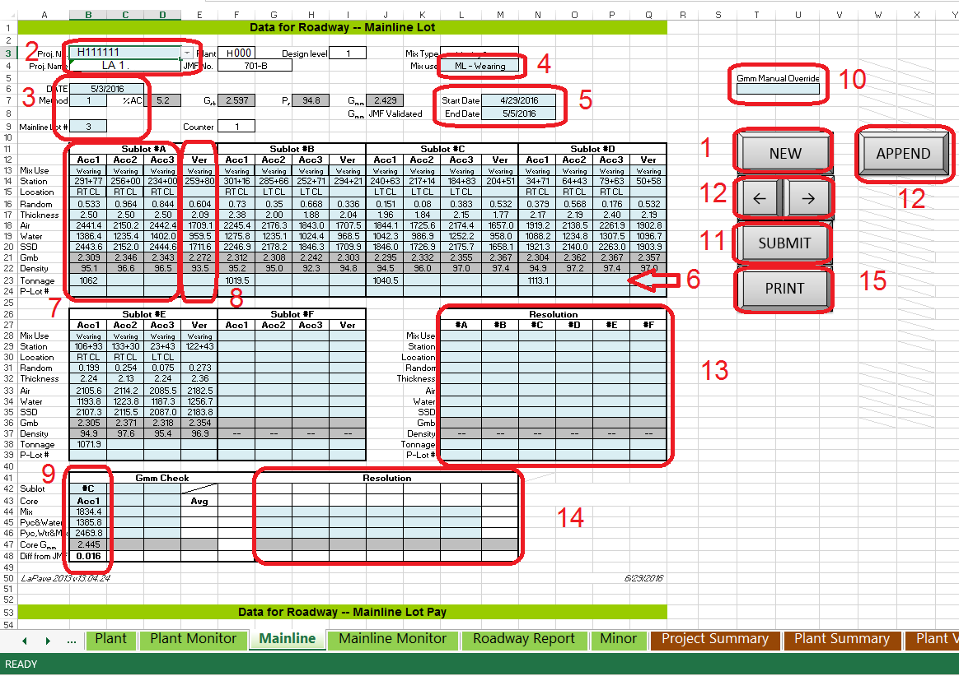

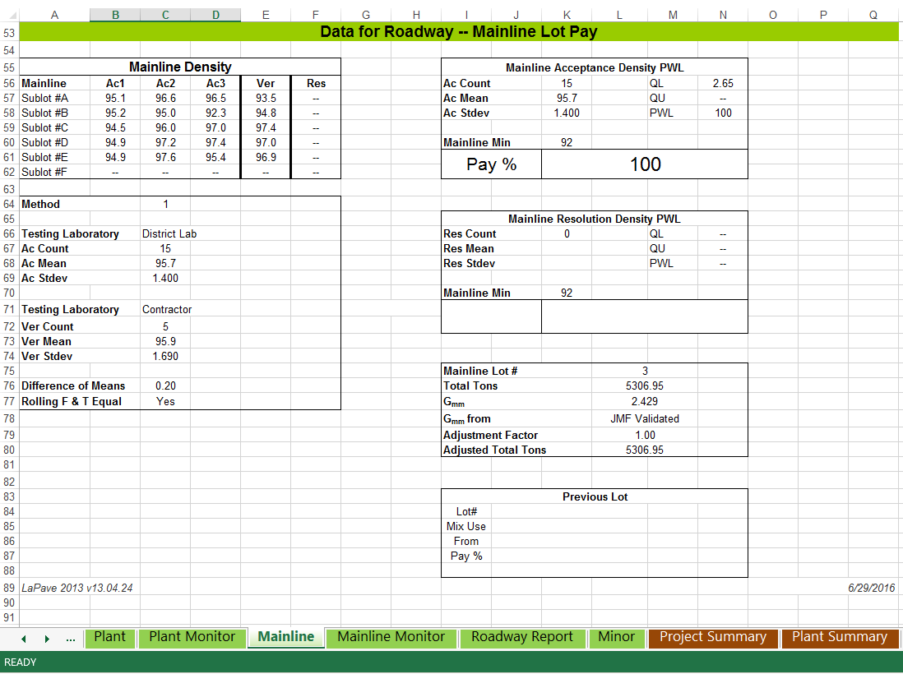

Mainline Monitor

The “Mainline Monitor” tab displays the “F & t” statistical information for a JMF.
It can calculate the for cores on a project or for all mainline information entered for a JMF.
- The information populated in the header is from the information displayed on the “Mainline” tab.
- The next area displays the date, Method 1 or 2, which mainline Lot # the data starts with & associated counter in LaPave. The higher the Mainline Lot # chosen on the previous tab (Mainline) the more data is used. The lot chosen to start the data analysis will also move the F & t test through the data set.
- The dropdown choices are all cores or project only cores. The project choice is filtered by which project on the “Mainline” is chosen.
- The statistical data.
- Note to point out that the lot chosen on the “Mainline” tab is where the data analysis starts. F & t only performed on “Mainline” core data.
- Print button to print the displayed data set.

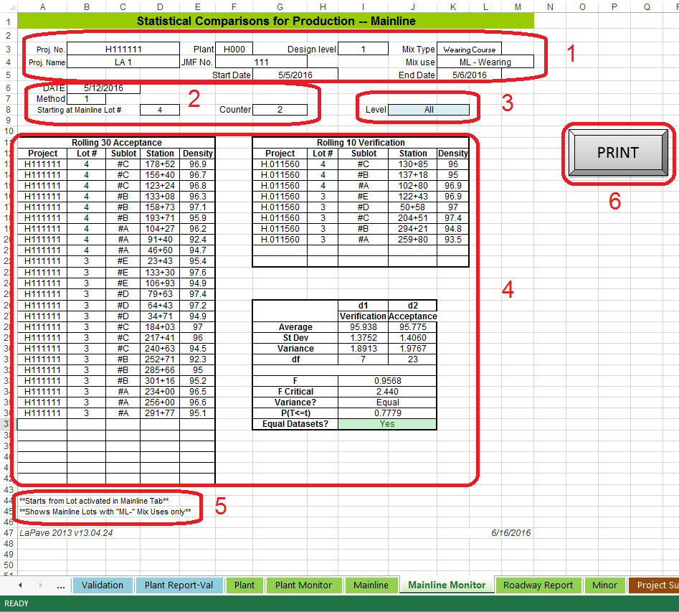

Roadway Report

This tab produces a summary of roadway data that is project specific.
- Choose the desired project from the dropdown. The associated information will populate.
- The dropdown will filer the information for Mainline, Minor, or Mainline and Minor mix use.
- Summary of roadway core information.
- Print a project summary of roadway data.
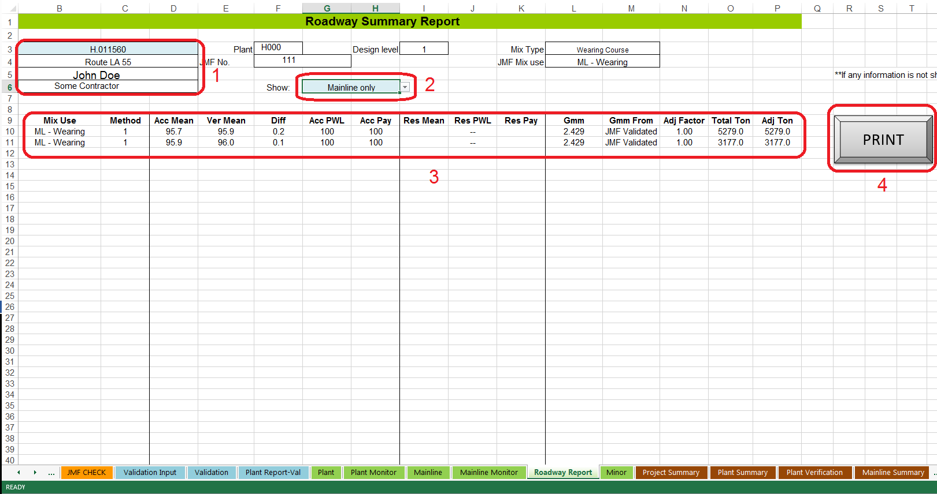
The summary tabs to the right of the “Roadway Report” tab contain the tables for the data entered in previously covered tabs.

Reporting
Various printouts can be made from the “Reporting” tab. Portions of the reports can be included or omitted with the “Y”/”N” dropdowns.
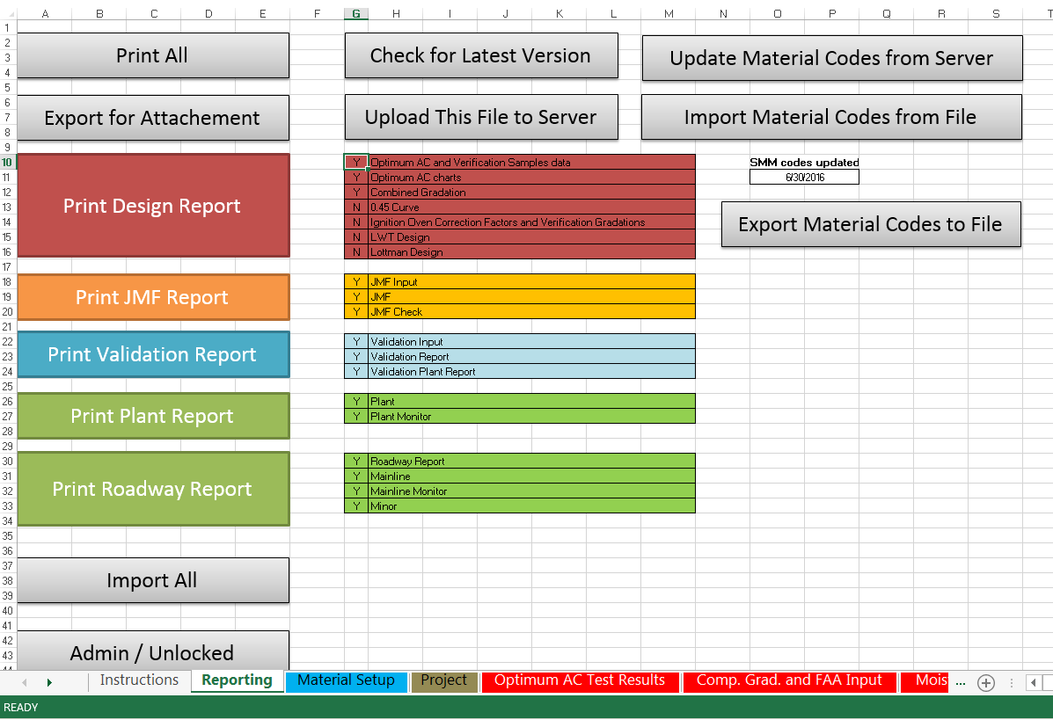
Asphalt Sampling, Testing & Inspection (Method 1) March 31, 2016 Luanna Cambas__________________________________________________________________________
DOTD Roadway Duties
Check roadway equipment.
Check tack rate.
Get haul tickets.
Check temperature of mix.
Check yield.
Choose locations for cores using random numbers.
Send acceptance and resolution cores to District Lab; GPC core to Matlab
Complete roadway report.
Observe contractor’s daily profiler set-up procedures, take IRI results.
___________________________________________________________________

Mainline Lots (92.0 min Density) 7500 LF Sublots 37,500 LF Lots
Travel lane base, binder and wearing; ramps > 300’, interstate accel/decel lanes,turn lanes.
Take 3 Acceptance cores per sublot = 15 per lot. (To District Lab)
Take 1 Verification core per sublot = 5 per lot. (To Plant)
Take 1 Resolution core per sublot = 5 per lot. (To District Lab)

Mainline Roadway Cores 37,500 LF LOT
7500 LF SUBLOT |  |  | 7500 LF SUBLOT |  |  | 7500 LF SUBLOT |  |  | 7500 LF SUBLOT |  |  |  | 7500 LF SUBLOT
A1 Core | A2 Core | A3 Core | A4 Core | A5 Core | A6 Core | A7 Core | A8 Core | A9 Core |  | A10 Core | A11 Core | A12 Core | A13 Core | A14 Core | A15 Core
V1 Core |  |  | V2 Core |  |  | V3 Core |  |  | V4 Core |  |  |  | V5 Core
R1 Core |  |  | R2 Core |  |  | R3 Core |  |  |  | R4 Core |  |  | R5 Core
For sublots < 7500 LF, take a minimum of 3 cores. (For < 250 tons, PE decides.)
___________________________________________________________________
Minor Lots (90.0 min Density) 1000 Ton Lots - Bike paths, crossovers, detour roads, leveling > 1.5” thick, parking lots, shoulders > 4’ wide, ramps < 300’, patching, and widening > 2.5’.
Take 3 minor cores per lot. (To District Lab) (For < 250 tons, PE decides.)

Minor Mix Cores 1000 TON LOT
333 TONS  M1 Core | 333 TONS  M2 Core | 334 TONS  M3 Core

Minor without density requirements – curbs, driveways, guardrail widening, islands, joint repair, spot leveling, medians, tapers, turnouts and shoulders ≤ 4’ paved with the roadway. (For < 250 tons, PE decides.)
Take 3 cores per project for Gmm verification. (To District Lab)
_________________________________________________________________
PROJECT --- Take 1 GPC core for asphalt cement verification (To Matlab)

